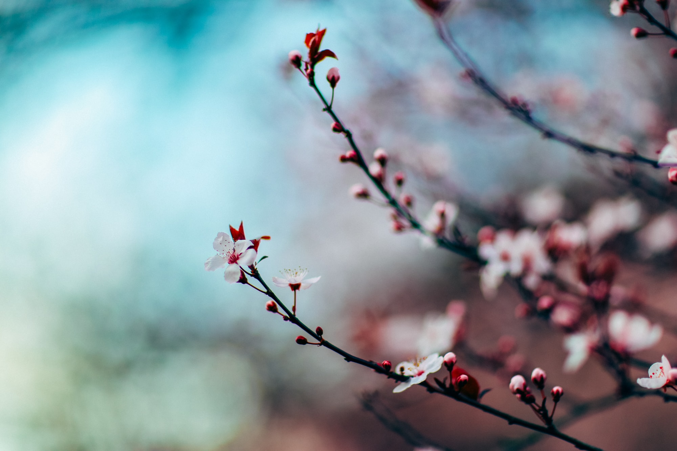
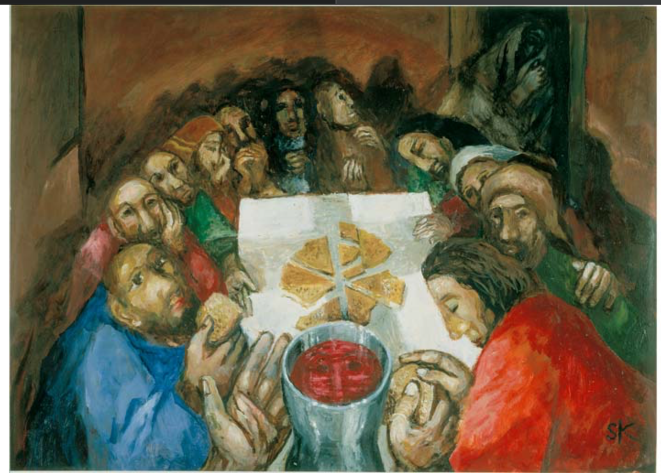

LENTEN Programs
We offer four exquisite video sessions devoted to reflections on the Passion of Christ as told through poetry and art. These slowed-down meditations will help us to behold the Paschal Mystery with new eyes.

Co-Facilitators:
Susan Muto, Lori McMahon, and Steve Geitgey
EPIPHANY INSTITUTE of FORMATIVE SPIRITUALITY
www.epiphanyassociation.org
900 Parish St.., Suite 316 • Pittsburgh, PA 15220 • 412-341-7494
You may watch these videos at your convenience. Upon registration, a comprehensive catalog of our featured poetry and art will be emailed to you, along with the video links.

COST: $40 for the series

Register via email: gerrie.epiphany@gmail.com OR CALL 412-341-7494
Celebration of Wholeness by Sieger Köder

Lenten Meditations with Poetry & Art

